RISK ASSESSMENT:
TYPE: WORKPLACE/
ACTIVITY/
HAZARD/
EQUIPMENT

Assessment Title:
Enter Here______________________
Assessed By:
Name of Assessor:

Date of Assessment:
Today’s Date

This template applies if employees:

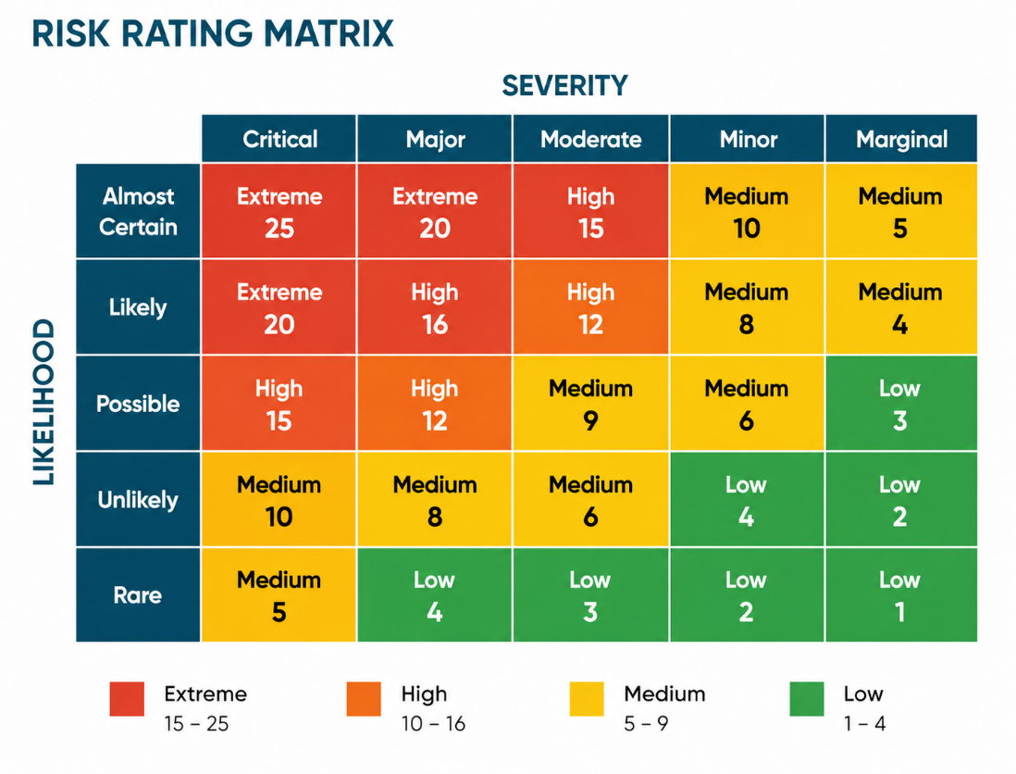

IMPORTANT:
This risk assessment template is provided by the Harwood Health & Safety Portal as a general guide only. It must be reviewed and adapted to reflect your specific workplace, activities, hazards and control measures.
Using this template without appropriate review and customisation does not constitute a suitable and sufficient risk assessment.

HOW TO USE THIS RISK ASSESSMENT
- Identify the hazards – look at the task, activity or workplace and identify anything that could cause harm
- Identify who might be harmed and how – consider employees, contractors, visitors and anyone else who could be affected
- Establish what harm could occur – describe potential injuries or incidents
- Record existing controls – list the control measures already in place to reduce the risk
- Calculate the risk - use the risk rating matrix to determine the risk rating (likelihood x severity)
- Decide on further controls – determine what additional activities are needed to reduce the risk further
- Assign responsibility – name the person or job role responsible for implementing the additional controls
- Set a date – create a target for when the additional controls need to be put into place
- Record the residual risk rating – reassess the risk after implementing further controls
- Review and update – review this assessment regularly and when there are changes to keep it accurate and up to date

1. | WHAT IS THE HAZARD?
1. | Describe what could cause harm

2. | WHO COULD BE HARMED?
2. | e.g. employees, contractors, visitors, members of the public etc

3. | WHAT HARM COULD OCCUR?
3. | Consider the potential consequences, including physical injury, work-related ill health and effects on mental wellbeing

4. | WHAT ARE YOU ALREADY DOING TO REDUCE THE RISK?  List the control measures in place
5. | CURRENT RISK RATING (with existing controls in place)  Use the risk rating matrix on the front page to score the risk
5. | Likelihood (L) | Severity (S) | Risk (L x S = R)

6. | WHAT ELSE DO YOU NEED TO DO?  Are there any additional control measures needed to reduce the risk further?

7. | WHO WILL TAKE ACTION?  Name or Job role | 8. | WHEN SHOULD THIS BE COMPLETED?  Target date

9. | RISK RATING AFTER ACTION (expected risk once action completed)
9. | Likelihood (L) | Severity (S) | Risk (L x S = R)

1. | WHAT IS THE HAZARD?
1. | Describe what could cause harm

2. | WHO COULD BE HARMED?
2. | e.g. employees, contractors, visitors, members of the public etc

3. | WHAT HARM COULD OCCUR?
3. | Consider the potential consequences, including physical injury, work-related ill health and effects on mental wellbeing

4. | WHAT ARE YOU ALREADY DOING TO REDUCE THE RISK?  List the control measures in place
5. | CURRENT RISK RATING (with existing controls in place)  Use the risk rating matrix on the front page to score the risk
5. | Likelihood (L) | Severity (S) | Risk (L x S = R)

6. | WHAT ELSE DO YOU NEED TO DO?  Are there any additional control measures needed to reduce the risk further?

7. | WHO WILL TAKE ACTION?  Name or Job role | 8. | WHEN SHOULD THIS BE COMPLETED?  Target date

9. | RISK RATING AFTER ACTION (expected risk once action completed)
9. | Likelihood (L) | Severity (S) | Risk (L x S = R)

1. | WHAT IS THE HAZARD?
1. | Describe what could cause harm

2. | WHO COULD BE HARMED?
2. | e.g. employees, contractors, visitors, members of the public etc

3. | WHAT HARM COULD OCCUR?
3. | Consider the potential consequences, including physical injury, work-related ill health and effects on mental wellbeing

4. | WHAT ARE YOU ALREADY DOING TO REDUCE THE RISK?  List the control measures in place
5. | CURRENT RISK RATING (with existing controls in place)  Use the risk rating matrix on the front page to score the risk
5. | Likelihood (L) | Severity (S) | Risk (L x S = R)

6. | WHAT ELSE DO YOU NEED TO DO?  Are there any additional control measures needed to reduce the risk further?

7. | WHO WILL TAKE ACTION?  Name or Job role | 8. | WHEN SHOULD THIS BE COMPLETED?  Target date

9. | RISK RATING AFTER ACTION (expected risk once action completed)
9. | Likelihood (L) | Severity (S) | Risk (L x S = R)

1. | WHAT IS THE HAZARD?
1. | Describe what could cause harm

2. | WHO COULD BE HARMED?
2. | e.g. employees, contractors, visitors, members of the public etc

3. | WHAT HARM COULD OCCUR?
3. | Consider the potential consequences, including physical injury, work-related ill health and effects on mental wellbeing

4. | WHAT ARE YOU ALREADY DOING TO REDUCE THE RISK?  List the control measures in place
5. | CURRENT RISK RATING (with existing controls in place)  Use the risk rating matrix on the front page to score the risk
5. | Likelihood (L) | Severity (S) | Risk (L x S = R)

6. | WHAT ELSE DO YOU NEED TO DO?  Are there any additional control measures needed to reduce the risk further?

7. | WHO WILL TAKE ACTION?  Name or Job role | 8. | WHEN SHOULD THIS BE COMPLETED?  Target date

9. | RISK RATING AFTER ACTION (expected risk once action completed)
9. | Likelihood (L) | Severity (S) | Risk (L x S = R)

1. | WHAT IS THE HAZARD?
1. | Describe what could cause harm

2. | WHO COULD BE HARMED?
2. | e.g. employees, contractors, visitors, members of the public etc

3. | WHAT HARM COULD OCCUR?
3. | Consider the potential consequences, including physical injury, work-related ill health and effects on mental wellbeing

4. | WHAT ARE YOU ALREADY DOING TO REDUCE THE RISK?  List the control measures in place
5. | CURRENT RISK RATING (with existing controls in place)  Use the risk rating matrix on the front page to score the risk
5. | Likelihood (L) | Severity (S) | Risk (L x S = R)

6. | WHAT ELSE DO YOU NEED TO DO?  Are there any additional control measures needed to reduce the risk further?

7. | WHO WILL TAKE ACTION?  Name or Job role | 8. | WHEN SHOULD THIS BE COMPLETED?  Target date

9. | RISK RATING AFTER ACTION (expected risk once action completed)
9. | Likelihood (L) | Severity (S) | Risk (L x S = R)

1. | WHAT IS THE HAZARD?
1. | Describe what could cause harm

2. | WHO COULD BE HARMED?
2. | e.g. employees, contractors, visitors, members of the public etc

3. | WHAT HARM COULD OCCUR?
3. | Consider the potential consequences, including physical injury, work-related ill health and effects on mental wellbeing

4. | WHAT ARE YOU ALREADY DOING TO REDUCE THE RISK?  List the control measures in place
5. | CURRENT RISK RATING (with existing controls in place)  Use the risk rating matrix on the front page to score the risk
5. | Likelihood (L) | Severity (S) | Risk (L x S = R)

6. | WHAT ELSE DO YOU NEED TO DO?  Are there any additional control measures needed to reduce the risk further?

7. | WHO WILL TAKE ACTION?  Name or Job role | 8. | WHEN SHOULD THIS BE COMPLETED?  Target date

9. | RISK RATING AFTER ACTION (expected risk once action completed)
9. | Likelihood (L) | Severity (S) | Risk (L x S = R)

1. | WHAT IS THE HAZARD?
1. | Describe what could cause harm

2. | WHO COULD BE HARMED?
2. | e.g. employees, contractors, visitors, members of the public etc

3. | WHAT HARM COULD OCCUR?
3. | Consider the potential consequences, including physical injury, work-related ill health and effects on mental wellbeing

4. | WHAT ARE YOU ALREADY DOING TO REDUCE THE RISK?  List the control measures in place
5. | CURRENT RISK RATING (with existing controls in place)  Use the risk rating matrix on the front page to score the risk
5. | Likelihood (L) | Severity (S) | Risk (L x S = R)

6. | WHAT ELSE DO YOU NEED TO DO?  Are there any additional control measures needed to reduce the risk further?

7. | WHO WILL TAKE ACTION?  Name or Job role | 8. | WHEN SHOULD THIS BE COMPLETED?  Target date

9. | RISK RATING AFTER ACTION (expected risk once action completed)
9. | Likelihood (L) | Severity (S) | Risk (L x S = R)

1. | WHAT IS THE HAZARD?
1. | Describe what could cause harm

2. | WHO COULD BE HARMED?
2. | e.g. employees, contractors, visitors, members of the public etc

3. | WHAT HARM COULD OCCUR?
3. | Consider the potential consequences, including physical injury, work-related ill health and effects on mental wellbeing

4. | WHAT ARE YOU ALREADY DOING TO REDUCE THE RISK?  List the control measures in place
5. | CURRENT RISK RATING (with existing controls in place)  Use the risk rating matrix on the front page to score the risk
5. | Likelihood (L) | Severity (S) | Risk (L x S = R)

6. | WHAT ELSE DO YOU NEED TO DO?  Are there any additional control measures needed to reduce the risk further?

7. | WHO WILL TAKE ACTION?  Name or Job role | 8. | WHEN SHOULD THIS BE COMPLETED?  Target date

9. | RISK RATING AFTER ACTION (expected risk once action completed)
9. | Likelihood (L) | Severity (S) | Risk (L x S = R)

1. | WHAT IS THE HAZARD?
1. | Describe what could cause harm

2. | WHO COULD BE HARMED?
2. | e.g. employees, contractors, visitors, members of the public etc

3. | WHAT HARM COULD OCCUR?
3. | Consider the potential consequences, including physical injury, work-related ill health and effects on mental wellbeing

4. | WHAT ARE YOU ALREADY DOING TO REDUCE THE RISK?  List the control measures in place
5. | CURRENT RISK RATING (with existing controls in place)  Use the risk rating matrix on the front page to score the risk
5. | Likelihood (L) | Severity (S) | Risk (L x S = R)

6. | WHAT ELSE DO YOU NEED TO DO?  Are there any additional control measures needed to reduce the risk further?

7. | WHO WILL TAKE ACTION?  Name or Job role | 8. | WHEN SHOULD THIS BE COMPLETED?  Target date

9. | RISK RATING AFTER ACTION (expected risk once action completed)
9. | Likelihood (L) | Severity (S) | Risk (L x S = R)

1. | WHAT IS THE HAZARD?
1. | Describe what could cause harm

2. | WHO COULD BE HARMED?
2. | e.g. employees, contractors, visitors, members of the public etc

3. | WHAT HARM COULD OCCUR?
3. | Consider the potential consequences, including physical injury, work-related ill health and effects on mental wellbeing

4. | WHAT ARE YOU ALREADY DOING TO REDUCE THE RISK?  List the control measures in place
5. | CURRENT RISK RATING (with existing controls in place)  Use the risk rating matrix on the front page to score the risk
5. | Likelihood (L) | Severity (S) | Risk (L x S = R)

6. | WHAT ELSE DO YOU NEED TO DO?  Are there any additional control measures needed to reduce the risk further?

7. | WHO WILL TAKE ACTION?  Name or Job role | 8. | WHEN SHOULD THIS BE COMPLETED?  Target date

9. | RISK RATING AFTER ACTION (expected risk once action completed)
9. | Likelihood (L) | Severity (S) | Risk (L x S = R)

RISK ASSESSMENT: Review & Sign-off
YOUR ACTION PLAN
OUTSTANDING ACTION | RESPONSIBLE PERSON | TARGET DATE | COMPLETED
COMMUNICATION
Relevant findings and control measures from this assessment must be communicated to employees and others who may be affected.
REVIEW THIS ASSESSMENT
This risk assessment should be reviewed if there is reason to believe it is no longer valid or following significant change to the work, workplace, equipment, processes or people affected.

Next planned review date:
ASSESSMENT COMPLETED BY | APPROVED/REVIEWED BY (if applicable)
Name: | Name:
Position: | Position:
Signature: | Signature:
Date: | Date:

