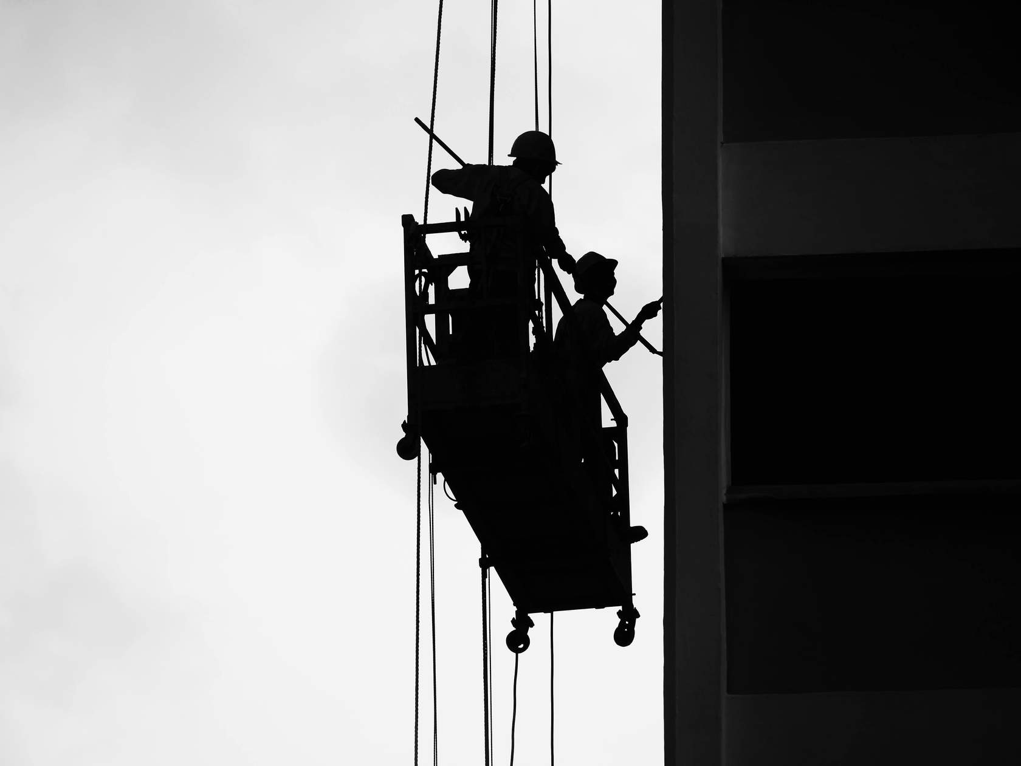Work at Height

Permit To Work

# Permit to Work

The permit to work is an extension of the safe system of work, not a replacement for it. The permit to work system does not, by itself, make the job safe. It supports the safe system of work, providing a means of ensuring people working at height are aware of the hazards; it ensures there is a formal check confirming elements of the safe system of work are in place before people work at height; it is used to record findings and authorisations required to proceed with the entry.

The permit to work **must** be completed by the Permit Issuer prior to persons working at height.

The Permit Issuers must check the following:

* Persons working at height are trained, competent and medically fit.
* Persons working at height or acting as Outside Person have read and understood the safe system of work and understand their responsibilities.
* Adequate emergency arrangements and communications are in place and have been briefed to those working at height, person acting as Outside Person and if required the rescue team.
* Hazards have been adequately controlled.
* Equipment is fully isolated and tested.
* Correct equipment and PPE has been issued.

Once the Permit Issuer is satisfied that the arrangements and controls are effectively in place they can sign the permit authorising start on work at height. The person responsible for carrying out the work at height must also sign as the Permit Holder, to accept responsibility for carrying out the task in the work at height and to the agreed safe work procedure. All members of the work team entering the work area must also sign on to the permit to confirm they have understood the requirements set out in the safe work procedure.

The **FIRST COPY** is posted in a prominent position at the work site/area. Where practicable it should be displayed with any other active permits to recognise potential conflicts in the work activities.

The **SECOND COPY** is given to the person carrying out the work (Competent Person). The BOTTOM COPY must be given back to the Authorised Person when the PTW is cancelled.

# Period of Validity of Permit to Work

A Work at Height Permit to Work will only be valid for the duration of work each day.

Permits cannot be issued for consecutive days/shifts. A new permit needs to be issued at the beginning of each new shift to ensure the oncoming manager fully understands the task, risks and has checked there are adequate controls in place. However, they can use the information provided from the first permit and simply review to check it is still valid – this would, therefore, only entail completing a new permit to work document and not all the supporting paperwork.

If there is a requirement for the Permit Issuer to leave site during the shift, the permit may be transferred to another competent responsible Permit Issuer. The job status, isolations and control measures must be checked. The new Permit Issuer must complete the handover section on the permit - by doing so they assume responsibility for the work undertaken.

# Permit Completion and Hand back

The permit is terminated at the completion of the work or due to the fact it is the end of the working shift. In either case, the Permit Holder shall indicate the work status on the permit and sign it off in the presence of the Permit Issuer.

If the situation changes, which takes the permit out of the scope of the work at height safe system of work, e.g. a weather warning is issued, then the permit must be cancelled, conditions re-assessed and the permit reintroduced safe weather conditions have been established.

The Permit Issuer shall accept the permit back when they are satisfied that all conditions are safe and/or the work area can be put back into operation. This shall be confirmed by signing off the permit.

# Emergency arrangements

The responsible person for planning the work must put in place adequate emergency arrangements before the work starts; this must be documented

in the safe system of work. Please note that if the Emergency Response Team is not available at the time the work at height is to be carried out, the job **cannot commence.**

**Work at Height - Permit to Work**

|  |  |  |
| --- | --- | --- |
| **Work at Height Entry Permit** (To be used for ALL Work at Height) **Permit No.:** | | |
| **Site Address:** | | |
| **Location on site:** | | |
| **Section 1 - Permit Receiver:-** *Delete as Appropriate* | | |
| **Business Maintenance Personnel** □ **Personnel 3rd Party Contractor** □ | | |
| **Contractor Details: -** | | |
| **Is any other work current being undertaken that may interact or affect this permit?** | | |
| **HAZARDS AND PRECAUTIONS**  **PRIMARY HAZARDS- Falls from Height, Unprotected Edges, Falling Objects, Improper use of Fall Arrest Systems, Adverse Weather Conditions, Fragile Surfaces, Electrical Hazards from Overhead Power Lines, Dizziness or Vertigo.**  **2 - Pre-Work Safety Information** (To be completed by the Permit Receiver)  Work cannot commence without the following information in place and ALL boxes below ticked where appropriate to those precautions that have been taken. | | |
| Are you qualified/trained to undertake this work? Yes | | No |
| Does the work require specific collective protective measures such as nets or airbags? Yes | | No |
| If scaffolding to be used - Has scaffolding been erected and checked by a  competent person? Yes | | No |
| Is a mobile elevated work platform to be used? Yes | | No |
| Are edge protection or toe boards required (roof or scaffolding)? Yes | | No |
| Are guard rails required? Yes | | No |
| Are harnesses required? - Have harnesses/lanyards been inspected and maintained? Yes | | No |
| Is the length of the lanyard correct for its intended use? Yes | | No |
| Are there sufficient fixing points for harness lanyards? Yes | | No |
| Warning signs/barriers and men at work signs in place? Yes | | No |
| Are there any existing overhead services or other obstructions crossing and/or  adjacent to the proposed height work? Yes | | No |
| Are there adequate emergency procedures in place? Yes | | No |
| Are weather/environmental conditions suitable? Yes | | No |
| Is there any risk from falling objects? Yes | | No |
| If ladders to be used - Have all ladders undergone a pre-use inspection? Yes | | No |
| **Hazards Assessed:** |  | |
| Dust Yes  No | Heat Yes  No | |
| Fumes Yes  No | Hot Parts Yes  No | |
| Gas Yes  No | Electrical Yes  No | |
| Steam Yes  No | Other (Specify) Yes  No | |
| Other Precautions Required | | |
| Other Safety Equipment Req’d | | |

|  |  |  |
| --- | --- | --- |
| **Any other information and further control measures** | | |
| **Section 3 - Authorisation and Acceptance**  I confirm that I have verified the above information and ensured that the necessary precautions have been taken and it is safe to carry out the work as defined above and the permit information has been explained to all work involved and I accept responsibility. | | |
| **Permit Receiver** (Print Name):- | | |
| **Signature:** | | |
| **Section 4 - Authorisation**  I authorise the above work to be carried out as detailed in the scope of works. | | |
| **Permit Issuer** (Print Name):- | | |
| **Signature:** | | |
| **Time of Issue:** | **Date:** | **Expiry Time:** |
| **Section 5 - Extension of Permit**  I hereby certify that I have reexamined the conditions covered under this permit and authorise its extension time noted below | | |
| **Permit Extended to Time:** | **Date:** | **Signature:** |
| **Time:** | **Date:** | **Signature:** |
| **Time:** | **Date:** | **Signature:** |
| **Time:** | **Date:** | **Signature:** |
| **Section 6 - Hand back & Cancellation** *Delete as Necessary  I confirm that the work has been *completed/*partially completed checked by myself & the area left in a safe condition | | |
| **Permit Receiver** (Print Name)**:-** | | |
| **Signature:** | | |
| **Time:** |  | **Date of Hand back:** |
| **Section 7 - Cancellation**  I have inspected the finished work, and the area has been left in a safe condition and hereby cancel this permit | | |
| **Permit Issuer** (Print Name): - | | |
| **Signature:** | | |
| **Time of Issue:** |  | **Date:** |