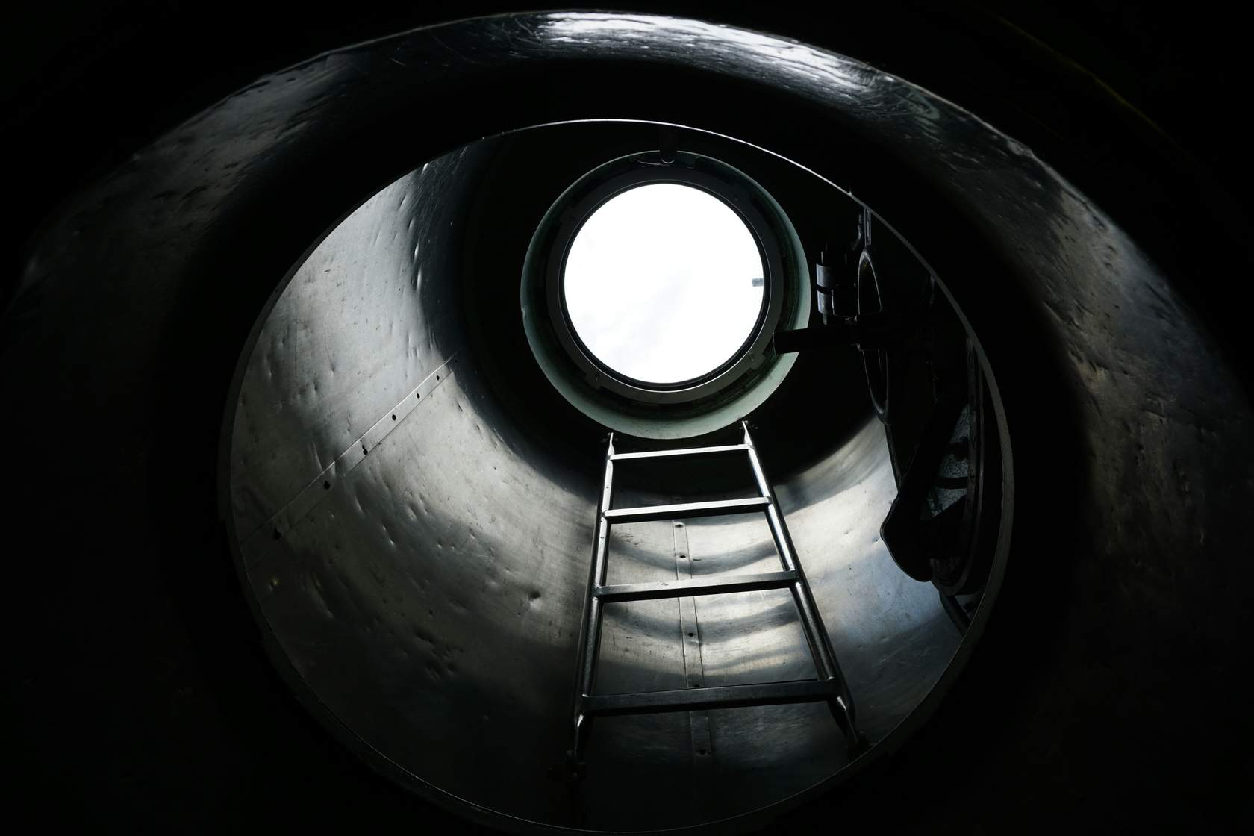
Confined Space Permit To Work

Permit to Work
The permit to work is an extension of the safe system of work, not a replacement for it. The permit to work system does not, by itself, make the job safe. It supports the safe system of work, providing a means of ensuring people working in confined spaces are aware of the hazards; it ensures there is a formal check confirming elements of the safe system of work are in place before people enter the confined space; it is used to record findings and authorisations required to proceed with the entry.
The permit to work must be completed by the Permit Issuer prior to persons entering a confined space.
The Permit Issuers must check the following:
- Persons entering the confined space are trained, competent and medically fit.
- Persons entering the confined space or acting as Outside Person have read and understood the safe system of work and understand their responsibilities.
- Adequate emergency arrangements and communications are in place and have been briefed to those entering the confined space, person acting as Outside Person and if required the rescue team.
- Hazards have been adequately controlled.
- Equipment is fully isolated and tested.
- Correct equipment and PPE has been issued.
- A pre-entry atmospheric test has been recorded and designated safe to enter.
Once the Permit Issuer is satisfied that the arrangements and controls are effectively in place they can sign the permit authorising entry into the confined space. The person responsible for carrying out the work in the confined space must also sign as the Permit Holder, to accept responsibility for carrying out the task in the confined space and to the agreed safe work procedure. All members of the work team entering the confined space must also sign on to the permit to confirm they have understood the requirements set out in the safe work procedure.
The FIRST COPY is posted in a prominent position at the work site/area. Where practicable it should be displayed with any other active permits to recognise potential conflicts in the work activities.
The SECOND COPY is given to the person carrying out the work (Competent Person). The BOTTOM COPY must be given back to the Authorised Person when the PTW is cancelled.

Period of Validity of Permit to Work
A Confined Space Entry Permit to Work will only be valid for the duration of work each day.
Permits cannot be issued for consecutive days/shifts. A new permit needs to be issued at the beginning of each new shift to ensure the oncoming manager fully understands the task, risks and has checked there are adequate controls in place. However, they can use the information provided from the first permit and simply review to check it is still valid – this would, therefore, only entail completing a new permit to work document and not all the supporting paperwork.
If there is a requirement for the Permit Issuer to leave site during the shift, the permit may be transferred to another competent responsible Permit Issuer. The job status, isolations and control measures must be checked. The new Permit Issuer must complete the handover section on the permit - by doing so they assume responsibility for the work undertaken.

Permit Completion and Hand back
The permit is terminated at the completion of the work or due to the fact it is the end of the working shift. In either case, the Permit Holder shall indicate the work status on the permit and sign it off in the presence of the Permit Issuer.
If the situation changes, which takes the permit out of the scope of the confined space safe system of work, e.g. gas alarm goes off, then the permit must be cancelled, conditions re-assessed and the permit reintroduced once normal gas levels have been established.
The Permit Issuer shall accept the permit back when they are satisfied that all conditions are safe and/or the work area can be put back into operation. This shall be confirmed by signing off the permit.

Emergency arrangements
The responsible person for planning the work must put in place adequate emergency arrangements before the work starts; this must be documented
in the safe system of work. Please note that if the Emergency Response Team is not available at the time the confined space work is to be carried out, the job cannot commence.

Confined Space - Permit to Work
Confined Space Entry Permit (To be used for ALL Confined Spaces) Permit No.:
Site Address:
Location on site:

Section 1 - Permit Receiver:- *Delete as Appropriate*
Business Maintenance Personnel □ Personnel 3rd Party Contractor □
Contractor Details:-
HAZARDS AND PRECAUTIONS
PRIMARY HAZARDS- Fumes, Electricity, Gases, Liquids, Sludge, Radiation, Moving Parts
Section 2 - Pre-Work Safety Information (To be completed by the Permit Receiver)
Work cannot commence without the following information in place and ALL boxes below ticked where appropriate to those precautions that have been taken.
Are you qualified/trained to undertake this work? Yes ☐ |  | No ☐
Has the confined space been Isolated from ALL connected pipework? Yes ☐ |  | No ☐
Has the confined space been purged with steam/water/air? Yes ☐ |  | No ☐
Has the confined space been isolated electrically and LOTOTO? Yes ☐ |  | No ☐
Has the confined space been isolated mechanically and LOTOTO? Yes ☐ |  | No ☐
Is the confined space below 30oC on full cooling? Yes ☐ |  | No ☐
Is a supply of respirable air assured/ventilation required? Yes ☐ |  | No ☐
Is there an acceptable means of access to and escape from the confined space? Yes ☐ |  | No ☐
Is breathing apparatus at hand and in good working order in case of emergency? Yes ☐ |  | No ☐
Is a safety tripod/line/harness and any other rescue equipment to hand? Yes ☐ |  | No ☐
Is continual gas monitoring to be used? Yes ☐ |  | No ☐
Are there adequate emergency procedures in place? Yes ☐ |  | No ☐
Is Personal Protective Equipment (PPE) required? Yes ☐ |  | No ☐
Are you likely to come into contact with asbestos?  If YES please refer to a specialist in Asbestos removal before work begins. Yes ☐ |  | No ☐
Is an atmosphere test required? If YES please complete section below Yes ☐ |  | No ☐
Time of Test 1: | Time of Test 2:
Oxygen % PASS ☐ FAIL ☐ | Oxygen % PASS ☐ FAIL ☐
Car-Mon % PASS ☐ FAIL ☐ | Car-Mon % PASS ☐ FAIL ☐
Car-Dioxide % PASS ☐ FAIL ☐ | Car-Dioxide % PASS ☐ FAIL ☐
Other (Specify) % PASS ☐ FAIL ☐ | Other (Specify) % PASS ☐ FAIL ☐
Other Precautions Required
Other Safety Equipment Required

Any other information and further control measures

Section 3 - Authorisation and Acceptance
I confirm that I have verified the above information and ensured that the necessary precautions have been taken and it is safe to carry out the work as defined above and the permit information has been explained to all work involved and I accept responsibility.
Permit Receiver (Print Name):-
Signature:

Section 4 - Authorisation
I authorise the above work to be carried out as detailed in the scope of works.
Permit Issuer (Print Name):-
Signature:

Time of Issue: | Date: | Expiry Time:
Section 5 - Extension of Permit
I hereby certify that I have reexamined the conditions covered under this permit and authorise its extension time noted below
Permit Extended to Time: | Date: | Signature:
Time: | Date: | Signature:
Time: | Date: | Signature:
Time: | Date: | Signature:
Section 6 - Hand back & Cancellation *Delete as Necessary
I confirm that the work has been *completed/*partially completed checked by myself & the area left in a safe condition
Permit Receiver (Print Name):-
Signature:
Time: |  | Date of Hand back:
Section 7 - Cancellation
I have inspected the finished work, and the area has been left in a safe condition and hereby cancel this permit
Permit Issuer (Print Name): -
Signature:
Time of Issue: |  | Date:

