DSE Workstation Assessment

**Notes for completion**:

Work through the checklist.

‘Yes’ answers require no further action.

‘No’ answers will require investigation and/or remedial action by the Manager or Supervisor. They should record their decisions in the ‘Action to Take’ column.

If the Business has DSE Assessors, they should follow up to ensure actions have been taken and resolved the problem.

|  |  |  |  |  |  |  |
| --- | --- | --- | --- | --- | --- | --- |
| **DSE Workstation Assessment type** | **Office** | **Hot desking** | | **Home/Remote** | | **Portable** |
| **DSE User Name:** |  | | **Manager/Supervisor Name** | |  | |

|  |  |  |  |  |  |
| --- | --- | --- | --- | --- | --- |
| **DSE Workstation Assessment** | | | | | |
| **Ref** | **Risk factor** | **Yes** | **No** | **If ‘No’ - Things to consider** | **Action to take** |
| **Furniture** | | | | | |
| 1 | Is the work surface large enough for all the necessary equipment, documents etc.? |  |  | Create more room by moving printers, reference materials etc. elsewhere. |  |
| 2 | Is the workstation set up so that users should be able to comfortably reach all the equipment and documents they will need to use? |  |  | Rearrange equipment, paper etc. to bring frequently used items within the easy reach zone.  A document holder may be needed, positioned to minimise uncomfortable head and eye movements. |  |
| 3 | Is the chair suitable?  (the chair should have working seat back, height/tilt adjustment, seat height adjustment, swivel mechanism, castors or glides and be stable) |  |  | The chair may need repairing or replacing if the user(s) find it uncomfortable, or adjustment mechanisms do not work. The chair arms should not obstruct the chair from getting close to the desk. |  |
| 4 | Are surfaces free from glare and reflection? |  |  | Consider mats or blotters to reduce reflections and glare. |  |
| **Display screen** | | | | | |
| 5 | Is the screen suitable for its intended use? |  |  | For example, intensive graphic work or work requiring fine attention to small details may require large display or multiple screens. |  |
| 6 | Are the characters clear and readable? |  |  | Make sure the screen is clean and cleaning materials are made available.  Check text and background contrast. |  |

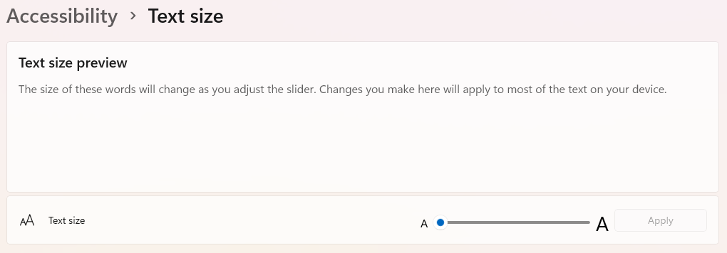

|  |  |  |  |  |  |
| --- | --- | --- | --- | --- | --- |
| **DSE Workstation Assessment** | | | | | |
| **Ref** | **Risk factor** | **Yes** | **No** | **If ‘No’ - Things to consider** | **Action to take** |
| 7 | Is the text size adjustable? |  |  | Software settings may need adjusting to change text size or zoom. |  |
| 8 | Is the image stable, for example free of flicker and jitter? |  |  | Try using different colours to reduce flicker, for example darker background and lighter text.  If problems still exist, you may need to replace your screen or graphics card with your computer. |  |
| 9 | Can the display settings be adjusted by a user? |  |  | Brightness, colours and contrast can be adjusted in Windows settings, and separate monitors have specific image settings that can be changed. |  |
| 10 | Is the screen adjustable or capable of being moved into a comfortable user position? |  |  | Standalone screens can generally tilt, rotate, swivel and be vertically adjusted. This mechanism can sometimes be added if it is not adequate.  Laptop screens can tilt, and the laptop itself swiveled, but laptop stands are recommended to ensure the correct height of the screen. |  |
| 11 | Is the screen free from glare and reflections? |  |  | Move the screen and/or shield it from the source of bright light or reflections. Dark characters on a light  background are less prone to glare and reflections. Check that blinds etc. work |  |
| **Keyboards** | | | | | |
| 12 | Is the keyboard separate from the screen? |  |  | This is a requirement, unless the task makes it impracticable (e.g. where there is a need to use a portable device such as a tablet). |  |
| 13 | Does the keyboard tilt? |  |  | Tilt need not be built in but can be adjusted with the keyboard “feet”, often found at the back, underneath the keyboard itself. |  |
| 14 | Is there adequate space in front of the keyboard to facilitate a comfortable keying position? |  |  | Try pushing the display screen further back to create more room for the keyboard, hands and wrists. Users of thick, raised keyboards may need a wrist rest. |  |
| 15 | Are the characters on the keys easily readable? |  |  | Keyboards should be kept clean. If characters can’t be read, the keyboard may need modifying or replacing. |  |

|  |  |  |  |  |  |
| --- | --- | --- | --- | --- | --- |
| **Mouse, Trackball etc** | | | | | |
| 16 | Is the device suitable for the tasks it is used for? |  |  | If the user is having problems, try a different device.  The mouse and trackball are general-purpose devices suitable for many tasks, and available in a variety of shapes and sizes.  Alternative devices such as touchscreens may be better for some tasks (but can be worse for others). Ergonomic mice could be assigned to users suffering from wrist pain from repetitive strain injury. |  |
| 17 | Can the device be positioned close to the user? |  |  | Most devices are best placed as close together as possible, for example beside the keyboard. |  |
| 18 | Is there a support for the user’s wrist and forearm? |  |  | Support can be gained from, for example, the desk surface or arm of a chair. If not, a separate supporting device may help.  The user should be able to find a comfortable working position with the device. |  |
| 19 | Does the device work smoothly and at a reasonable speed? |  |  | See if cleaning is required, for example the mouse or work surfaces.  Check the work surface is suitable for the mouse being used |  |
| 20 | Can the settings be easily adjusted for the speed and accuracy of the mouse. |  |  | Users may need training in how to adjust the mouse settings* |  |

*PC Users can access mouse settings in the ‘Bluetooth & devices section’ of the settings menu. These settings can include pointer speed, scrolling speed and other settings depending upon the type of mouse that is connected to the machine.

Mac Users will be able to find their mouse settings depending on the version of macOS that their machine is running

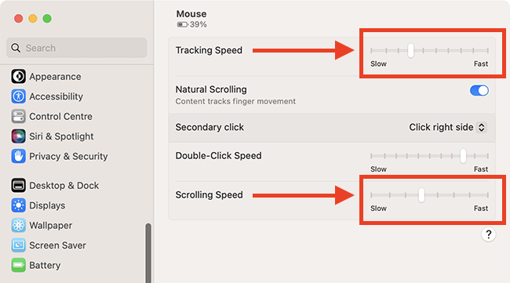

|  |  |  |  |  |  |
| --- | --- | --- | --- | --- | --- |
| **DSE Workstation Assessment** | | | | | |
| **Ref** | **Risk factor** | **Yes** | **No** | **If ‘No’ - Things to consider** | **Action to take** |
| **Working environment** | | | | | |
| 21 | Is there enough room to change position and vary movement? |  |  | Space is needed to move and stretch.  Consider reorganising the office layout and check for obstructions.  Cables should be tidy and not a trip or slip hazard. |  |
| 22 | Is the lighting suitable, for example not too bright or too dim to work comfortably? |  |  | Users should be able to control light levels, for example by adjusting window blinds or light switches.  Consider shading or repositioning light sources or providing local lighting, e.g. desk lamps without producing glare themselves |  |
| 23 | Does the air feel comfortable? | ☐ | ☐ | Display screens and other equipment may dry the air.  Circulate fresh air if possible. Plants may help.  Consider a humidifier if discomfort is severe. |  |
| 24 | Are levels of heat comfortable? |  |  | Can heating be better controlled? More ventilation or air-conditioning may be required if there is a lot of electronic equipment in the room. Or can users be moved away from heat sources |  |
| 25 | Are levels of noise comfortable? |  |  | Consider moving sources of noise, e.g. printers, away from the user. If not, consider breaking up the sound with barriers such as shields or plants etc |  |

**Additional comments –** Detail any other problems that the checklist may not have covered:

|  |  |  |  |  |  |  |  |  |
| --- | --- | --- | --- | --- | --- | --- | --- | --- |
| **Recording DSE Workstation Assessment Actions** | | | | | | | | |
| The Manager, Supervisor or delegated DSE assessor **must** record below the recommended actions to take in order to resolve the issue(s) identified in the DSE workstation assessment. The assessor **must** review the actions once they have been implemented to make sure they have resolved the problem. | | | | | | | | |
| **Recommended actions to take** | | | | | | | | |
| **Ref No** | **Action** | | **Person Responsible for Action (Name)** | | | **Due Date** | **Have actions**  **resolved the**  **problem?\*** | |
|  |  | |  | | |  | **YES**  **NO** | |
|  |  | |  | | |  | **YES**  **NO** | |
|  |  | |  | | |  | **YES**  **NO** | |
|  |  | |  | | |  | **YES**  **NO** | |
| **\*Note:** If the actions haven’t resolved the problem, then the issue will need to be reassessed, and new actions developed. | | | | | | | | |
| **Is a specialist DSE assessment required?** | | **YES**  **NO** | |  | | | | |
| **Assessor’s name** | |  | | | **Date** | | |  |
| **DSE Assessment - Review** | | | | | | | | |
| **Timeframe (**i.e., two year or a significant change ) **and/or reason for review\*\*** | |  | | | | | | |

**\*\*Note:** The DSE workstation assessments **must** be reviewed if there is a significant change to the workstation, or if the DSE Users situation changes.